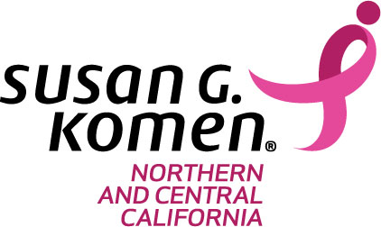

FOR IMMEDIATE RELEASE | Contact: Kelly Mac Millan
 | Phone: 916.757.0574
 | Email: kmacmillan@komennccalifornia.org

SUSAN G. KOMEN® NORTHERN & CENTRAL CALIFORNIA TO PREMIER NEW MORE THAN PINK WALK EVENT IN 2018

New Name/Approach Improves Experience and Connection to Komen’s Lifesaving Work

SACRAMENTO, CA, February 6 - Susan G. Komen Northern & Central California told supporters today to expect changes at its annual Sacramento Race for the Cure® fundraising walk held in the spring, as the organization has been hard at work on the next evolution in the history of the Race for the Cure® series.

Sacramento and its residents were selected to be one of four locations across the country to pilot and experience a new Susan G. Komen More Than Pink® Walk event, which includes a new name, fresh look, and a new opening ceremony experience focused on energizing the community around the lifesaving work Komen’s supporters make possible.

This new approach is based on input from participants across the country, and by Komen’s observations from years as the leader in breast cancer walks.

“Much of what you have come to love about the Race will continue with our new More Than Pink Walk,” explained Kelly Mac Millan, Executive Director, Susan G. Komen Northern & Central California. “These changes are intended to increase people’s connection to our work beyond breast cancer awareness. Together, we are more than pink–a community of people who want to do more for research, more for our communities, more for those among us who are living with breast cancer – including metastatic breast cancer – and more action to get us to cures.”

The most significant difference this year is that the More Than Pink Walk will not have a separate timed run element, focusing instead on the walk which reflects the vast majority of the event’s participants historically. This change will create a greater sense of community among participants and will provide a more personalized, emotional experience for all who attend. Without expenses associated with a separate timed run, Komen will maximize the amount of funds raised by the event available to save lives and end breast cancer.

Mac Millan believes these changes will be positive for the community, adding, “We’re excited about this new chapter and encourage everyone to register and begin fundraising! We look forward to seeing everyone walking on May 12, 2018, for a day of inspiration and hope in support of all those living with breast cancer, and those who have survived, and to remember and celebrate the lives we’ve lost to the disease."

WHAT: 2018 Komen Sacramento More Than Pink Walk
WHEN: Saturday, May 12, 2018
WHERE: Cal Expo, 1600 Exposition Blvd, Sacramento, CA 95815
MORE INFORMATION: Register or learn more online at https://komennccalifornia.org/walk

About Susan G. Komen® and Komen Northern and Central California - Susan G. Komen is the world’s largest breast cancer organization, funding more breast cancer research than any other nonprofit while providing real-time help to those facing the disease. Komen has set a Bold Goal to reduce the current number of breast cancer deaths by 50 percent in the U.S. by 2026. Komen was founded in 1982 by Nancy G. Brinker, who promised her sister, Susan G. Komen, that she would end the disease that claimed Suzy’s life. Komen Northern and Central California has invested $22 million in community breast health programs in 29 counties and has helped contribute to the more than $956 million invested globally in research. For more information, call our Sacramento office at 916.231.3148, Fresno office at 559.229.4255, or visit KomenNCCalifornia.org.

###

For more information about this event and what changes to expect, please visit https://komennccalifornia.org/walk online or call 916.231.3148.

